Dear Potential Sponsors,
The Harlan Park Athletic Association (HPAA) is currently seeking sponsors for our 2026 Youth Baseball/Softball season. As a result of the generous sponsorships by businesses such as yours, our association has the privilege of positively contributing to the youth of our community. Your support not only benefits the children in our area, but also you and your business as a viable means of advertising to your direct market. We expect as many as three hundred children, as well as their friends and family members, to be at our ball parks this year. Don’t miss out on this great opportunity to increase your exposure though this much needed sponsorship.
Option 1 - Team & Sign Sponsor…$450.00 (SAVE $50.00)
Sponsors will have their business name displayed on t-shirts of that designated team along with a 4’X4’ sign to be displayed on the diamond fence. In addition, you will receive a team plaque that you may proudly hang in your place of business.

Option 2 - Team Sponsor Only……$300.00
All Team Sponsors will have their business name displayed on t-shirts of that designated team.

Option 3 - Sign Sponsor Only……...$200.00
All Sign Sponsors will receive a 4’X4’ sign which will be displayed on the diamond fence.
To ensure all shirts and signs are printed in time, our deadline for sponsorship is March 18th, 2026. We appreciate your consideration and would like to thank you in advance for your continued generosity and community support. Should you have any questions regarding sponsorship or the Harlan Park Athletic Association, please feel free to contact Tony Hevel at (260) 705-2050 (TEXT MESSAGE).
Sincerely,
Harlan Park Athletic Association
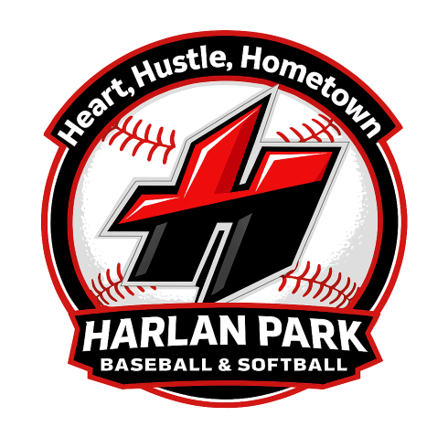

Business Info
Business Name:
Contact Name:
Business Address:
Phone Number:
Team Color(s) Preference:

Sponsorship Selection | Selection
Team & Sign Sponsorship - $450.00
(SAVE $50.00)
Team Sponsorship Only - $300.00
Sign Sponsorship Only - $200.00

Send Sponsorship Form as well as Logo/Artwork to thevel16@gmail.com and zmcclish@gmail.com

Please make all checks payable to Harlan Park Athletic Association and mail to P.O. Box 505 Harlan, IN 46743 by March 18, 2026

